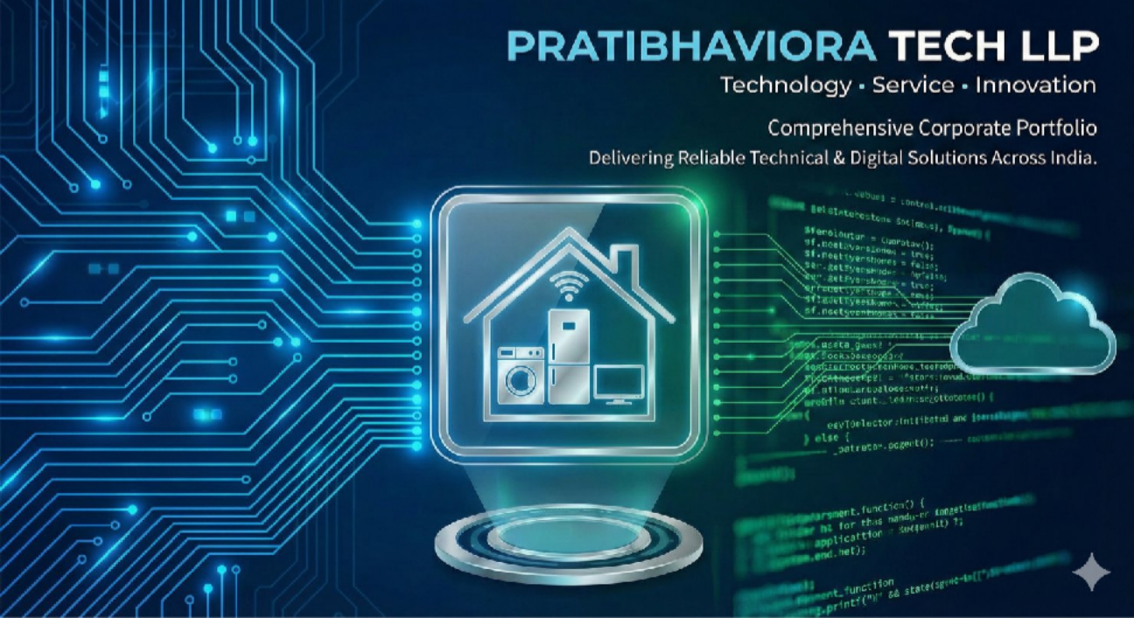
PRATIBHAVIORA TECH LLP

Technology That Works as Hard as You Do.

Expert IT Support | Hardware Repair | Digital Solutions

When your technology stops, business stops. We are here to ensure that never happens.

PRATIBHAVIORA TECH LLP
Your Trusted Technology Partner

WHO WE ARE



More Than Just "Tech Support"

PRATIBHAVIORA TECH LLP is a professionally managed technology service organization providing complete technical support across Information Technology infrastructure, consumer home appliances, and modern software development. We were formed to offer dependable, affordable, and high-quality services to businesses and households under one roof..
We act as a reliable service partner, taking responsibility for installation, maintenance, troubleshooting, and innovation to ensure technology always works smoothly.
We do things differently.

We take ownership of your IT infrastructure. From the moment you call us, your technical problem becomes our responsibility to solve—quickly, honestly, and permanently.

Vision, Mission &Values


v

Our Vision

To become India’s most trusted technology and service brand, where customers rely on us without hesitation for fast, professional, and consistent quality service nationwide. We aim to be more than a service provider; we become a strategic technology partner.

Our Mission
- Deliver quick solutions to reduce downtime.
- Use skilled technicians and modern tools.
- Provide affordable pricing and transparent communication.
- Ensure customer satisfaction after every job.
Our Core Values
- Integrity: Honest and ethical business practices.
- Quality: High standards in every service.
- Speed: Quick response and closure.
- Commitment: Taking full responsibility.
- Innovation: Using modern technology.
- Customer First: Client satisfaction is our priority.

CORE EXPERTISE – IT Infrastructure Services

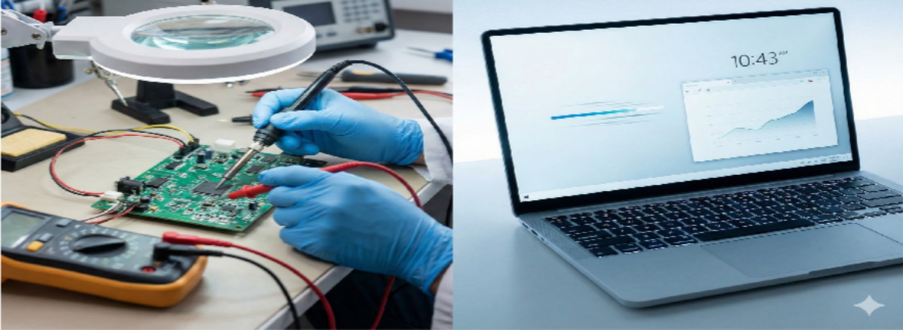

Goal: Reduce downtime and improve productivity
We manage and maintain IT hardware systems for organizations to ensure business operations continue without interruption. Our trained engineers provide on-site installation, preventive maintenance, breakdown repair, upgrades, and replacement services.

Key Offerings:
- Desktop & Laptop Support: Motherboard repair, RAM/SSD replacement, OS installation, virus removal, performance optimization, data backup, and troubleshooting.
- Printer, Networking & CCTV Services: Printer installation and repair, network cabling and configuration, router and switch setup, Wi-Fi troubleshooting, and CCTV installation and monitoring.
IT AMC & Helpdesk Model
Our Annual Maintenance Contract (AMC) ensures complete support throughout the year with a full process from complaint registration to closure.
- Advantages: Fixed cost, priority support, preventive visits, less downtime, and better asset management.

"Don't replace it if we can fix it."
We focus on extending the life of your existing assets, saving you significant capital in the long run.

Software Development Services

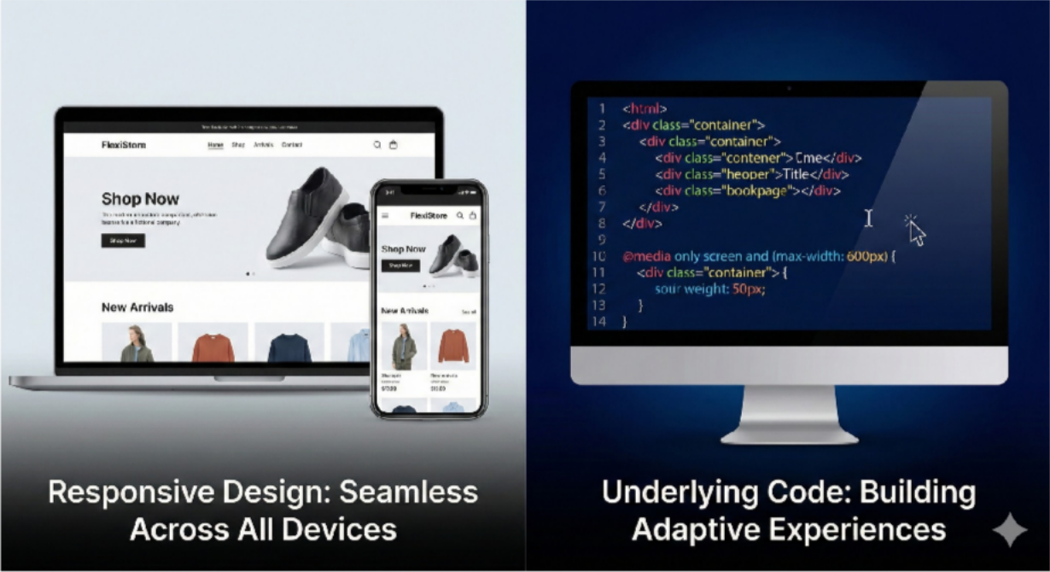

Digital technology is essential for business growth

We design customized software to automate processes and improve efficiency. Our team analyzes business requirements and develops scalable and secure solutions tailored to client needs

Key Offerings:
- Corporate Websites
- E-commerce Platforms
- Android/iOS Mobile Apps
- ERP Systems & CRM Solutions
- Cloud Applications
- Maintenance & Upgrades

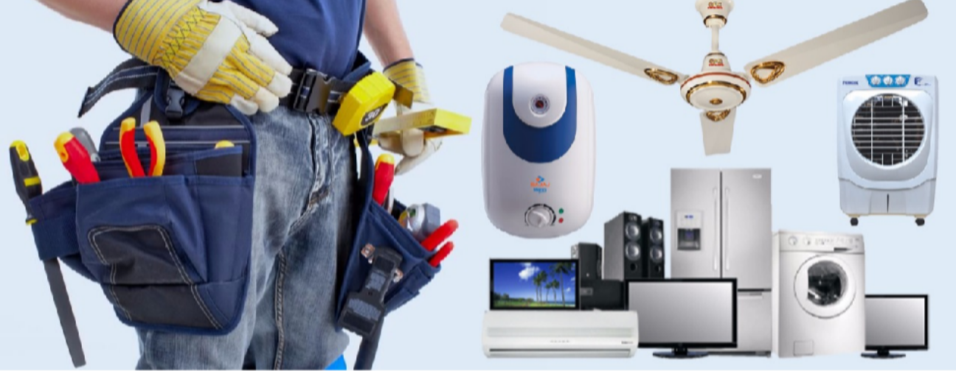
Home Appliance Services

Expert care for your daily necessities.

We provide doorstep repair and maintenance for consumer appliances for residential and retail customers. Our technicians carry tools and genuine spare parts to ensure quick repairs, with a goal of same-day or next- day service.

Services Explained:
- LED/LCD/Smart TV repair
- Washing machine servicing
- Refrigerator gas charging and repair
- Microwave and kitchen appliances
- AC installation and maintenance
- Spare parts replacement Service Workflow:
To maintain professionalism, we follow a structured workflow from customer complaint receipt to job closure, ensuring accountability and transparency.

OUR SERVICE MODELS (How We Work)
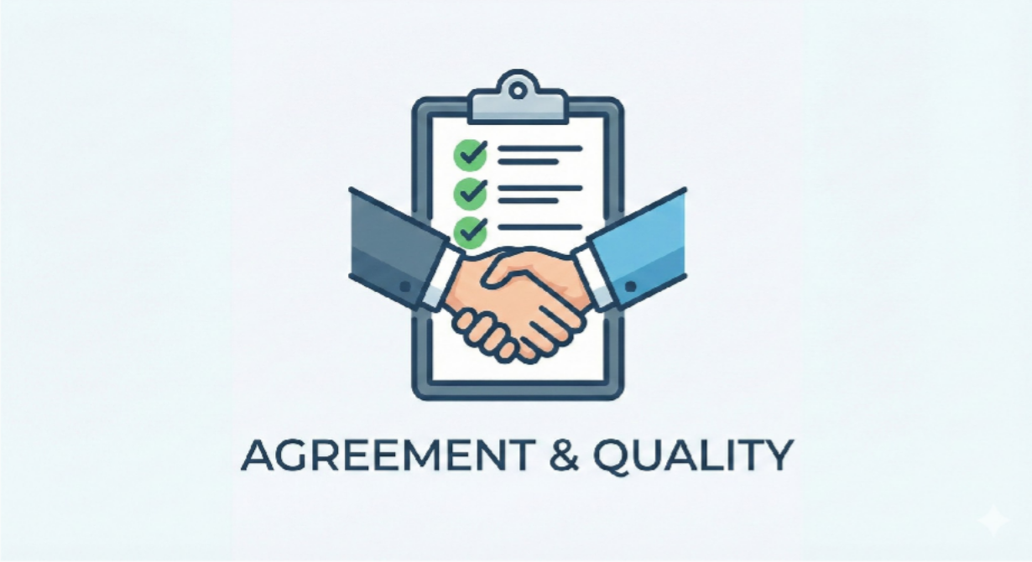

Flexible Engagement Model
We know every business has different needs. We offer flexible ways to engage our services.

- On-Demand Breakdown Support
  - Best for: Small offices or individuals.
  - How it works: You face an issue -> You call us -> We visit and fix it.
  - Pricing: Transparent, per-visit pricing. No hidden costs.

- Annual Maintenance Contracts (AMC)
  - Best for: Corporate offices, Schools, and Institutions.
  - The "Peace of Mind" Plan: For a fixed annual fee, we take complete care of your IT assets.
    - Unlimited breakdown calls.
    - Preventive Maintenance Visits: We visit quarterly to clean and service machines
before they break.
    - Priority response time.
    - Standby backup equipment (optional add-on).

WHY CHOOSE US?

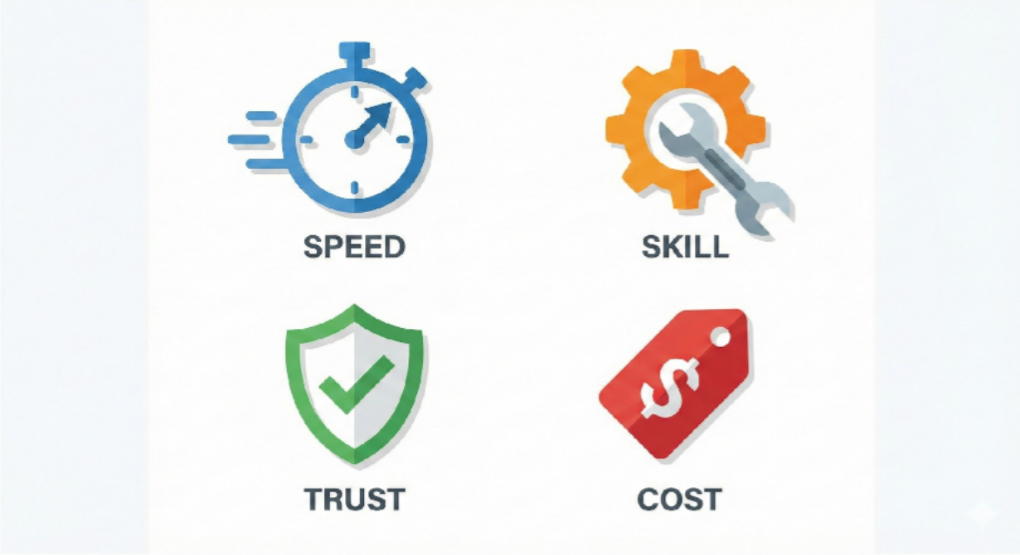

The Pratibhaviora Advantage

In a crowded market of service providers, here is why our clients stay with us year after year:

  - Technical Depth: We understand the electronics inside the box. Our diagnosis is accurate, reducing trial-and-error costs.
  - Response Time: We know downtime costs money. Our logistics network ensures we reach your site fast.
  - Genuine Spares Only: We never compromise on quality. We use original or high-grade compatible parts with warranty support.
  - Human Support: No automated bots. When you call us, you talk to a human who understands technical issues.

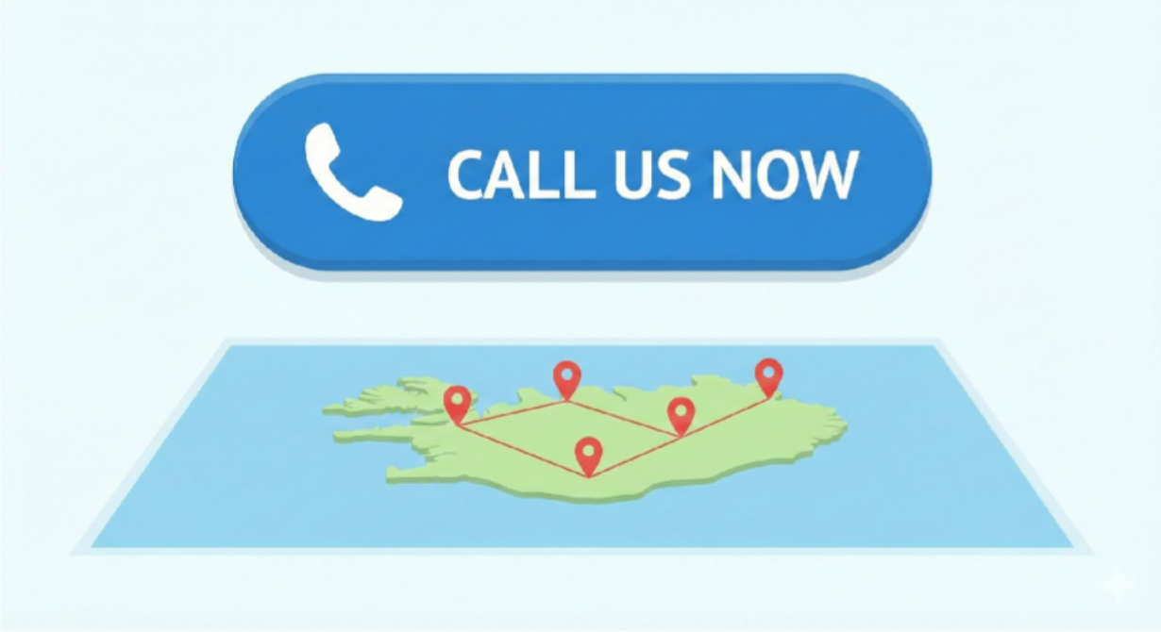

Your Trusted Technology Partner

PRATIBHAVIORA TECH LLP is more than a service provider – we are your complete technology partner. We welcome opportunities to collaborate with government departments, corporate organizations, institutions, and individual customers.
Why Clients Trust Us:
- Professional approach & quick response time
- Skilled and certified engineers
- Transparent pricing & quality assurance
- Long-term support and customized solutions

Contact Us
Let us power your technology with trust, quality, and innovation

  - Phone: +91-9838644528
  - Email: pratibhaviora@gmail.com
  - Website: www.pratibhaviora.com
  - Registered Office: Ghaziabad, Uttar Pradesh

PRATIBHAVIORA TECH LLP

Technology • Service • Innovation

